|  |  |  |  |  |  |  |  |  |  |  |  |  |  |
| --- | --- | --- | --- | --- | --- | --- | --- | --- | --- | --- | --- | --- | --- |
| **MAD Project Evaluation 2 – Regular Intake 2021** | | | | | | | | | | | | | |
| **Project Name:** | AppDevelopers2.0_G6 | | **Batch:6** |  | | | |  |  |  |  | | |
| Student ID | Student Name | Integrated system using a repository (Out of 5) | Marketing the app using a video clip published in a social media account (e.g.: LinkedIn) (Out of 10) | CRUD Function completeness (Out of 20) | Database connectivity (Out of 5) | Usability (Out of 5) | Validations (Out of 5) | Good coding practice (Out of 5) | Out of box features (Out of 10) | Test cases (Out of 10) | Report (Out of 10) | Q & A (Out of 15) | Total (Out of 100) |
| IT20226114 | Ekanayaka N.G.R. P |  |  |  |  |  |  |  |  |  |  |  |  |
| IT20119812 | K.K Walalawela |  |  |  |  |  |  |  |  |  |  |
| IT20120702 | Warnakulasooriya M.K. W |  |  |  |  |  |  |  |  |  |  |
| IT20178154 | Dilshan P.A.D.S.D |  |  |  |  |  |  |  |  |  |  |
|  |  |  |  |  |  |  |  |  |  |  |  |

Git Repository Link: … https://github.com/RasikaEkanayake/One_Click_travel.git ……………………………………………………………………………………………………………………………………………………………………………………………..

Link for the video in social media : https://www.instagram.com/p/CUSHHfMhXtz/?utm_medium=copy_link

(All group members must be tagged)

----------------------------------------------------------------------------------------------------------For Evaluators---------------------------------------------------------------------------------------------------------

Evaluator’s name:

1. **Introduction to the project**



* This report outlines the implementation of the Tour assist mobile application. This shows the flow of events through which the activities in the application navigate throughout the application. This includes the CRUD operations and the calculations. This emphasizes the interfaces in the application with its performance and runtime implementations.

Scope of the Project.

This One Click Travel application is used inside the boundary of Sri Lanka.

This application is not capable of booking destinations. This is designed in a way to assist the users to support them when they travel to a destination. It gives us features such as reserving rooms and tourist-guides. In this application the end user can be either a normal person or an administrator.

Special cases in the mobile application

1. Administrator can add, update, and delete rooms and guide information.
2. Administrator can calculate the total income using the app.
3. The list of rooms and the guides are listed to the general customers to book them.
4. Customers should first sign up (for the first time) to the application.
5. Using the login credentials, they are first navigated to their profile and then to the main homepage.
6. When they choose a category, they can either make a card payment or use PayPal.
7. Also, there is rating for the app. users can submit their experience about using the application.
8. This app contains two sides one is customer side and another one is administrator side.

**IT20226114 Ekanayaka N.G.R.P -**

**Create an Account**

When it comes to the Create an Account page there are two buttons named **Customer** and **Guide.**

By clicking on Customer button, I can log in to the Create Account for Customers page. Here I can create an account for our customers by adding their personal details. Under the details there is a **Submit** button. Here we mainly consider about First & Last Name, Email and Password.

When we click on the Guide button the same method happens as above. The difference between customer account and guide account is guide has to submit more information than customer. Such as age, price language etc.

**Income**

After successfully logging to the Payment Received Page I collect and sort out all the details in to two main categories, Customer and Guide. Then I calculate the summary of the received payment and display in the main display.

Calculate Expense

Delete User details

Edit User details

Retrieve User details

This is main login

Retrieve Income details

Insert user

Insert user

Income retrive

User Password change

Validations

**IT20119812 Walalawela K.K-**

**Manage Guidebooks**

After successfully logging to the Manage Guidebooks it displays two buttons named **Add Books** **&** **Edit Books**. By clicking Edit Books button we can easily enter to the page which can manage tourist guidebook details. Here we can update a new book to the system and delete a current book. There are separate buttons named **Update** and **Delete** to each function.

**Manage Tourist Guide Details**

When it comes to the Tourist Guide Details, we can update the system by adding their latest personal information such as Email, Contact details and Price. There is a button named **Edit**. By clicking on that we can **Update** or **Delete** details. There are three separate buttons to each operation.

**Select guid methods insert guide edid guid details retrieve and delete edit guide salary details**

**Connect to firebase database**

**Insert Guide to database**

**Retrieve Guide details**

**Delete and search guide**

**IT20120702 Warnakulasooriya M.K.W-**

**Booking Guide Page**

After login to the home page, it displays a booking tourist guide button. After clicking the button, it redirects to the booking guide page. This page has a list of available guides. The customer can select the guide as they wish. Then customer redirect to the page which have their selected guide’s details and their prices, and this page has two buttons call calculate total and proceed to pay. Customer must enter the number of days that they wish to tour with the guide. Then they must click the calculate total and then they must click the proceed to pay button to pay the guide.

**Book tourist guide button. List of available guide page. The page that needs to enter no of days.**

**Payment Page**

The payment page has two buttons call PayPal and Credit Card. Customer can select any payment methods from these two. If a customer selects PayPal, he or she redirect to the PayPal payment page. This page has indicated their total prices and discounts and a final price. The customer must enter the PayPal email address and click the submit email button which the page has. Then the customer redirect to another page which has their entered email address. This page has two buttons which are proceed and update. If the customer needs to update their email, he or she can enter the new email and click the update button and then click the proceed button. If they don’t need to update the email, they can simply click the proceed button, then the email is sending to their PayPal account. Then they can pay the payment by it. And the payment is shown in their PayPal account. If customer click credit card button, he redirects to the credit card payment page. This page has two buttons, they are submitting details and view my card details. This page also indicates the total prices and discounts and a final price. Customers need to enter their card details and click the submit button. Then the page prompt a successful message. Then customer need to click view my card details. Then customer redirect to the card details page. This page has two buttons call delete and pay. Customer can click delete button if they wish to delete their card details or he or she can click the pay button if the details above are correct.

**Select the payment method. Enter the PayPal email address. Proceed to pay and the message is The page to enter credit card Page that indicates credit**

**sending to the details. Card details (Viee my**

**customer’s PayPal account. Card)**

**Navigate to payment method and search and table connection**

**Getting details from payment**

**Email insert**

**Delete**

**Retrieve**

**Validation view card details**

**IT20178154 Dilshan P.A.D.S.D-**

**ADD New Room, UPDATE Rooms, DELETE Room, Reserve Room, Calculate Room Payment**

After successfully log in to the application system display home page and there’s a manage room button. After entered to the manage room page there is two buttons. One button is **Add New** **Room** and other one is **View Room** button. In Add New Room page there is a small form that admin can add new room details to the database. He can add details of Room Location, Room Description, price, and special room features.

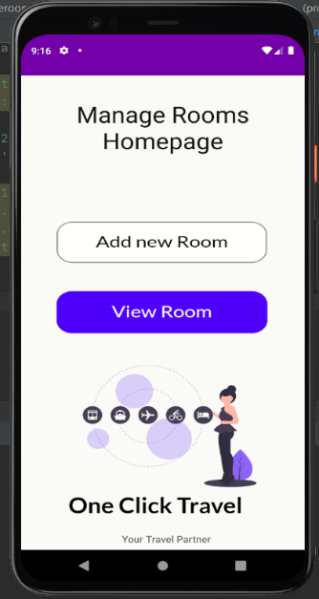

In view rooms there is a list of rooms that stored in database. We can edit room details by touching **edit button** and it will redirect to Edit Room Detail page. User can update the room details and submit using Update Room button. And all so he can delete all the room details by touching **Delete Room** button.

Admin can Create, Update, Delete details about rooms.

After login user can Book a room using **Book Room** button. After touching book rooms button system redirect to page that shows available rooms. user can touch Reserve button. then system show a page that can calculate total price for a booking and touching Payment Page button system redirect to payment page. Pop ups and push notification are used when submitting details

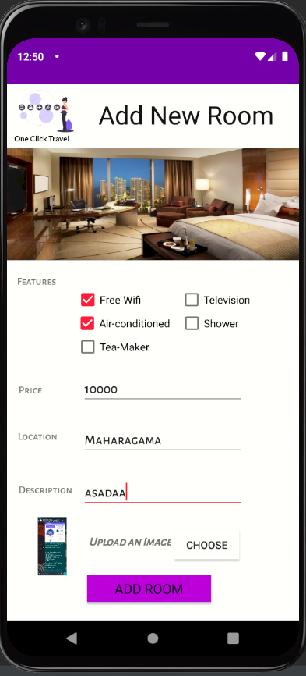 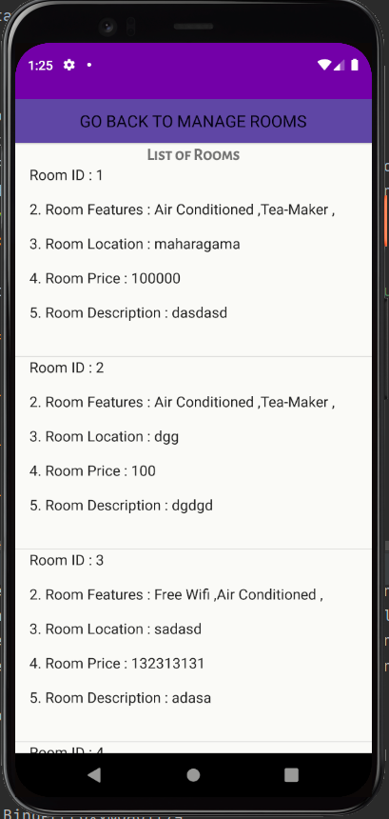 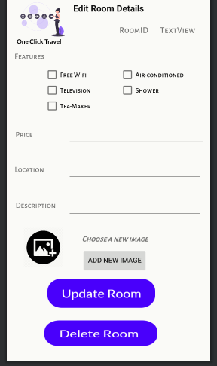

**This is the add new room page. After adding room, it will display on we can delete and update rooms using**

**Admin Add new rooms using this page this page this page**

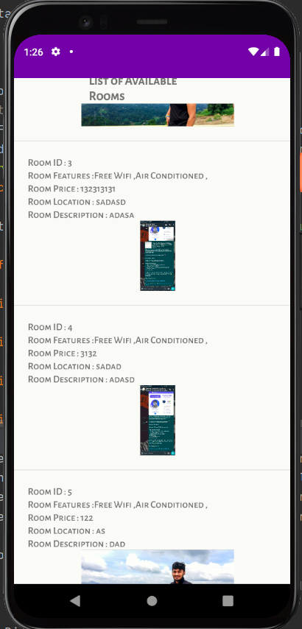 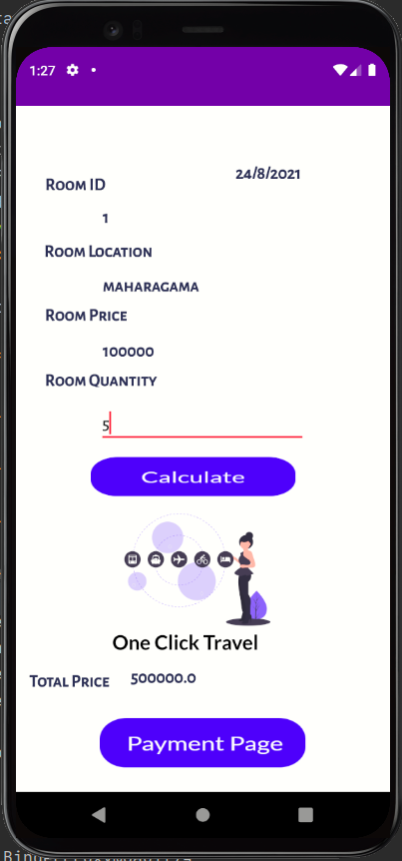 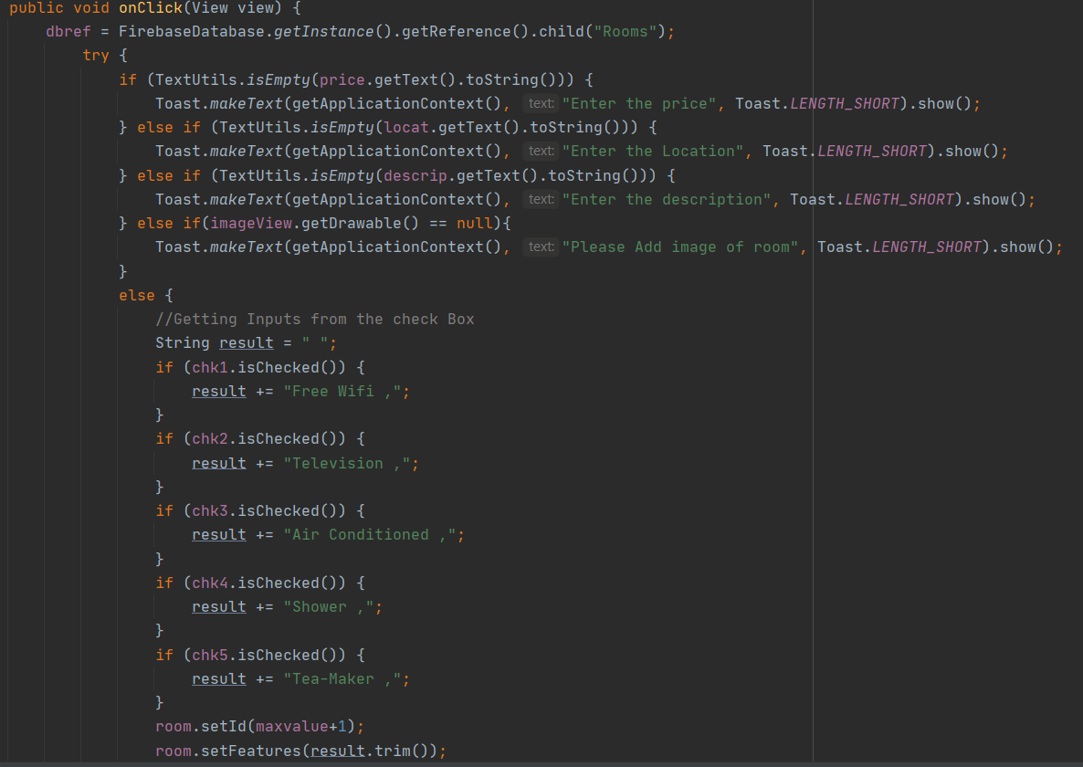**

**using this page Create**

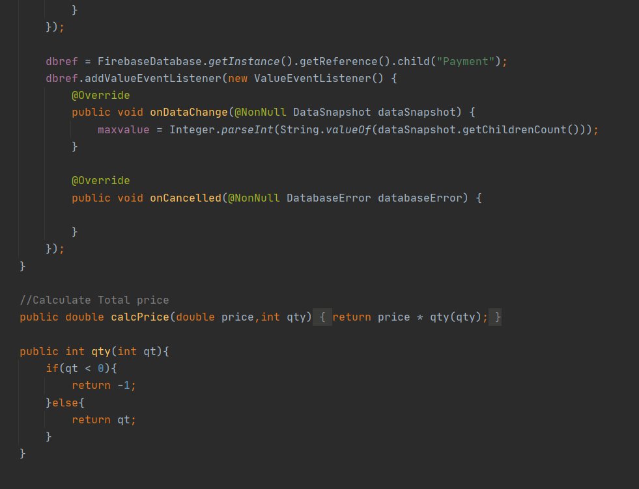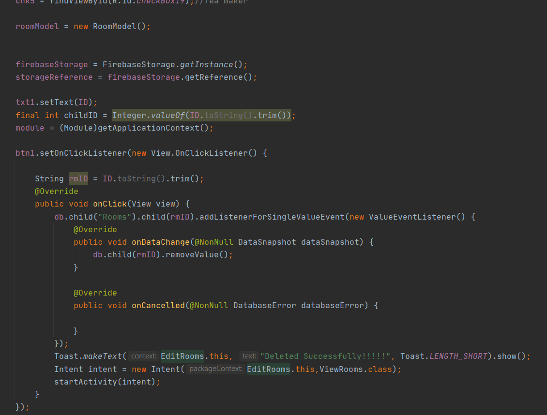

C**alculate Delete**

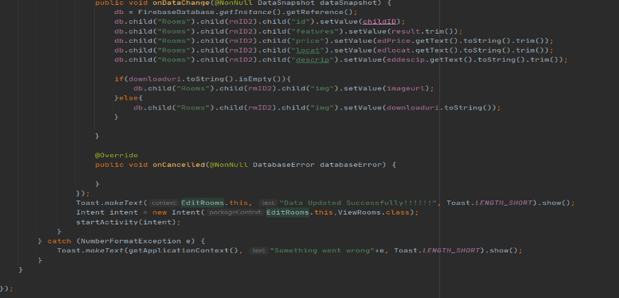  **Update**